Higher National Diploma in Information Technology
HNDIT11062 – Web Development
First Year- Semester I

Lab Activity 07

- Create a webpage that prints your name to the screen and set its title to "This is a webpage".
- Prints the numbers 1 - 10 to the screen, each number being a different color.
- Create paragraph with 4 - 5 sentences. Each sentence should be a different font.
- View the outputs of the following HTML codes.

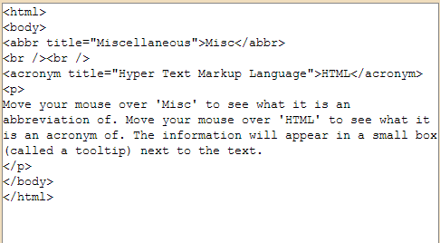

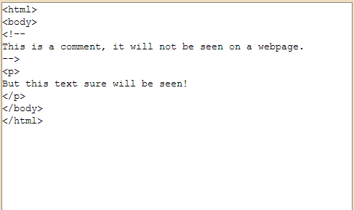

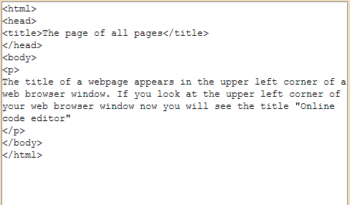

- Print a paragraph that is a description of a book, include the title of the book as well as its author. Names and titles should be underlined, adjectives should be italicized and bolded.
- Print the squares of the numbers 1 - 20. Each number should be on a separate line, next to it the number 2 superscripted, an equal sign and the result. (Example: 10² = 100)
- Create the following web pages.

